RESTATED BYLAWS OF THE
LOW-LEVEL RADIOACTIVE WASTE FORUM, INC.
as amended on June 11, 2025

ARTICLE I
Registered Office

Section 1. Registered Office. The registered office of the Low-Level Radioactive Waste Forum (the "Forum") shall be as set forth in the Articles of Incorporation, or in the most recent amendment of the Articles of Incorporation, or in the most recent statement filed with the Secretary of State of Minnesota changing the registered office.

Section 2. Other Offices. The Forum may have other offices at such other places within and without the state of Minnesota as the Board of Directors may from time to time determine.

ARTICLE II
Definitions

Section 1. Membership categories

- "Compacts" means Congressionally approved interstate compacts formed in accordance with the federal Low-Level Radioactive Waste Policy Act of 1980 and the Low-Level Radioactive Waste Policy Amendments Act of 1985.

- ''Non-Affiliated State" means individual states that are not affiliated with a regional Compact.

- "Host State" means individual states that are designated by a Compact to establish and host a regional commercial low-level radioactive waste disposal facility and individual states that currently host a commercial low-level radioactive waste disposal facility.

Non-voting Membership categories

- “Federal Associates” means Federal agencies such as the Nuclear Regulatory Commission, Environmental Protection Agency, Department of Energy, Department of Defense, or any other Federal agency.

- “Non-Federal Associates” means corporations and other interested parties.

ARTICLE III
Purpose

The general mission of the Forum's business and the objects and purposes for which it is formed are:

- Facilitating the implementation of the federal Low-Level Radioactive Waste Policy Act of 1980 and the Low-Level Radioactive Waste Policy Amendments Act of 1985 (collectively, the "Legislation"); and

- Bringing together a diverse group of stakeholders on a regular basis to promote sharing of ideas, concepts, and solutions; and

- Educating and informing policy makers and the public about the management and disposal of low-level radioactive waste and about the aims of the federal legislation; and

- Fostering innovative information sharing among state and interstate compact officials; and

- Providing opportunities for state and interstate Compact officials to exchange views with federal officials and other interested parties; and

- Supporting the mission of interstate Compacts and working to ensure continued access to licensed low-level radioactive waste disposal capacity; and

- To engage in all such other activities and to exercise all such other powers permitted to corporations under applicable law that are incidental to or connected with the foregoing business or purposes or are necessary or desirable to accomplish the foregoing; provided, however, that the Forum shall at all times be operated exclusively for the promotion of any or all of the charitable or educational purposes contemplated by Section 50l(c)(3) of the Internal Revenue Code of 1986, including any amendments thereto, as well as any related provisions thereof adopted by future amendments to the extent such provisions are applicable to the Forum.

ARTICLE IV
Board of Directors

Section 1. Powers. The Board of Directors of the Forum shall constitute its governing body and shall have such powers and authority as shall be conferred upon them by the Articles of Incorporation, the Bylaws and the Statutes of the State of Minnesota under which the Forum is organized.

Section 2. Appointment, Number and Terms; Alternates. The Board of Directors of the Forum shall consist of not less than three (3) persons. The initial Board of Directors shall consist of the persons designated by the incorporator of the Forum. Thereafter, the Board of Directors shall consist of one appointee from each Compact, each Non-Affiliated State, and each Host State (the Compacts, Non-Affiliated States and Host States are sometimes collectively referred to as the "Appointing Authorities"). The appointees from each Compact shall be designated by the Compact Commission established in each Compact; appointees from each Non-Affiliated State and each Host State shall be designated by the Governor or a cabinet-level designee who serves in a state government position that is appointed by the Governor, of each such state.

The term of office of each Director shall be designated by the applicable Appointing Authority.

In addition to the appointment of a Director, each Appointing Authority, or its Director if authorized by the Appointing Authority, may designate not more than two Alternate Directors to represent and vote for the Appointing Authority in the event the Director is unable to participate in a meeting of the Board of Director.

Section 3. Vacancies. The Board of Directors at any meeting may accept the resignation of any Director submitted in writing. Any vacancy occurring among the Board of Directors by reason of death, resignation, the creation of new Directorships or any other circumstance, shall be filled by the Compact Commission of the Compact the departing Director represents, or, as applicable, by the Governor or a cabinet-level designee or a designee who serves in a state government position that is appointed by the Governor of the Non-Affiliated State or Host State the departing Director represents.

Section 4. Director Conflicts of Interest. The Forum shall not enter into any contract or transaction with (a) one or more of its Directors, (b) a Director of a related organization (within the meaning of Minnesota Statutes, section 317A.0l 1, subd. 18), or (c) an organization in or of which a Director is a Director, officer or legal representative or has a material financial interest; unless the material facts as to the contract or transaction and as to the Director's interest are fully disclosed or known to the Board of Directors, and the Board of Directors authorizes, approves, or ratifies the contract or transaction in good faith by the affirmative vote of a majority of the Directors (without counting the interested Director), at a meeting at which there is a quorum without counting the interested Director. Failure to comply with the provisions of this Section 2.4 shall not invalidate any contract or transaction to which the Forum is a party. This Section does not authorize any act of "self-dealing" as defined in Section 4941(d) of the Internal Revenue Code.

Section 5. Removal. Any Director may be removed from office at any time, with or without cause by the Appointing Authority that has appointed such Director. Vacancies created by removal shall be filled in the manner described in Section 3 of this Article.

Section 6. Committees. A standing Executive Committee is established by resolution on October 16, 2025 and shall act on behalf of the Board in the management of the business of the Forum between meetings of the full Board. The Executive Committee is comprised of the Officers of the Board.

A standing Finance Committee is established by resolution on October 16, 2025 and is responsible for maintaining accurate and complete financial records of the organization; preparing and presenting accurate, timely and meaningful financial statements to the Board; helping the Board understand the organization’s finances; budgeting and anticipating financial problems; safeguarding the organization’s assets; and managing the Board’s portfolio of reserve funds. The Finance Committee is comprised of the Board’s Past-Chair, Treasurer, and one Director-at-large that is assigned by resolution of the Board.

The Board may designate such other committees as it may deem necessary and shall establish by resolution the authority of such committees.

All Committees, standing or otherwise, shall at all times be subject to the direction and control of the full Board, and any actions taken by the Committee shall be reported to the full Board at the next full Board meeting.

ARTICLE V
Meetings

Section 1. Annual Meeting. The annual meeting of the Board of Directors for the purpose of electing officers and transacting such other business as may properly come before the meeting shall be held at the time and place, within or without the state of Minnesota, designated from time to time by the Board of Directors. The annual meeting may be held virtually or in-person.

Section 2. Monthly Meeting. Monthly scheduled meetings may be held at the discretion of the Board Chair. Monthly meetings may be scheduled as part of the current monthly meeting to ensure quorum participation. The monthly meeting may be held virtually or in-person.

Section 3. Other Meetings. Other meetings of the Board of Directors may be held at such time and place as are announced at a previous meeting of the Board of Directors. Meetings of the Board of Directors may also be called at any time (a) by the Chair of the Board, (b) by the Board of Directors, or (c) by the Executive Committee (if one is established). Anyone entitled to call a meeting of the Board of Directors may make a written request to an Officer to call the meeting, and the Officer shall give notice of the meeting, setting forth the time, place and purpose thereof, by mailing or by faxing or by electronically transmitting the same to each Director at his or her residence or business address at least two (2) weeks before the meeting or by delivering same personally to the Director at least one (1) week before the meeting; or any combination of delivery by mail, by electronic mail, by facsimile or in person provided the time specified for each type of notice is complied with. No notice need be given to any Director from whom a written consent or waiver of notice for a particular meeting has been received by an Officer.

Section 4. Quorum. At all meetings of the Board of Directors a quorum shall consist of one more than half of all Directors currently holding office as a Director. If a quorum is not present, the meeting may be adjourned from time to time for that reason and any business which might have been transacted at the meeting as set forth in the notice thereof may be transacted at the adjourned meeting if a quorum is then present.

Section 5. Voting. Only Directors or alternate Directors, as applicable, present in person at the meeting may vote. There shall be no cumulative voting nor any voting by mail and each Director or alternate Director, as applicable, shall be entitled to only one vote on any matter brought before any meeting of the Board; provided, however, that any Director or alternate Director, as applicable, who is representing more than one Appointing Authority shall be entitled to cast one vote for each such Appointing Authority. There may not, however, be more than one vote cast for each Appointing Authority. Unless otherwise required by law or by the Articles of Incorporation or by some other provision of these Bylaws, a majority of the votes cast shall govern in every matter voted upon.

Section 6. Electronic Communications. A Director may participate in a meeting by any means or communication through which such person, other persons so participating, and all persons physically present at the meeting may simultaneously hear each other during the meeting. Participation in a meeting by that means constitutes presence in person at the meeting. A conference among Directors by any means of communication through which such persons may simultaneously hear each other during the conference is a meeting of the Board of Directors, as the case may be, if the same notice is given of the conference as would be required for a meeting, and if the number of persons participating in the conference would be sufficient to constitute a quorum at a meeting. Participation in a meeting by that means constitutes presence in person at the meeting.

ARTICLE VI
Officers

Section 1. General. At their annual meeting, the Board of Directors shall from among its members elect one or more persons to exercise the functions of the offices of Chair of the Board, Chair-Elect, Past-Chair and Treasurer, and any other officers deemed to be necessary by the Board.

The Chair-Elect is elected to that office for a one-year term and automatically advances to the office of Chair of the Board for a subsequent one-year term. Upon expiration of a Chair's term of office, that person automatically becomes Past-Chair for a one-year term. The Treasurer is elected to office for a three-year term. For the purpose of these by-laws, a term of office expressed in terminology relating to the "year" shall be considered to include that period of time that begins with the close of the Annual Meeting and extends through the conclusion of the next Annual Meeting, unless the calendar year is specifically designated.

In any case, all of the officers serve until their successors are chosen and take office. Any officer may be removed at any time, with or without cause, by resolution of not less than a majority of the Directors in attendance at the meeting at which such removal is considered.

Section 2. Chair of the Board. The Chair of the Board shall preside at Board meetings when present; see that all orders and resolutions of the Board are carried into effect; sign and deliver in the name of the Forum any deeds, mortgages, bonds, contracts or other instruments pertaining to the business of the Forum, except in cases where the authority to sign and deliver is required by law to be exercised by another person or is expressly delegated by the Articles or Bylaws or by the Board to some other officer or agent of the Forum; maintain records of and, where necessary, certify all proceedings of the Board; concern himself or herself with matters of long-range policy, direction and growth, and perform such other duties as the Board of Directors may designate from time to time.

Section 3. Executive Director. The Board may hire an Executive Director who shall be in charge of all normal day-to-day operations of the Forum and shall perform such other duties as the Board of Directors may designate from time to time. The Executive Director shall keep or cause to be kept minutes of all meetings of the members and of the Board of Directors.

Section 4. Past-Chair. The Past-Chair shall perform all duties imposed upon him or her by these Bylaws as well as the duties commonly incident to this office and perform all the duties and exercise such other powers as the Board of Directors may designate from time to time.

Section 5. Chair-Elect. The Chair-Elect performs the duties imposed upon him or her by the Chair of the Board as well as acting for the Chair in his or her absence, as well as duties commonly incident to this office and performs all duties and exercise such other powers as the Board of Directors may designate from time to time.

Section 6. Treasurer. The Treasurer shall keep or cause to be kept full and accurate records showing all receipts and disbursements of the Forum and shall deposit or cause to be deposited all monies and other valuable effects of the Forum in its name and to its credit in such depository or depositories as may be designated by the Board of Directors from time to time. These deposits may include financially conservative investments such as Certificates of Deposit, Money Market Accounts, High Yield Savings Accounts, or Stable Value Funds. The Treasurer may use investment strategies provided by the Forum’s depository to evaluate investment opportunities. The Treasurer, with approval from the Board of Directors, may hire a third-party company or companies to assist in bookkeeping activities and auditing activities.

The disbursement of all funds over $1,000 of the Forum shall be submitted to and approved by two of the following: Chair of the Board, Chair-Elect, Past Chair, or Treasurer. The Treasurer or third-party bookkeeping firm shall ensure proper vouchers or receipts for all such disbursements or payments shall be taken from the recipient thereof. A full written report of all receipts and disbursements of money and property of the Forum shall be rendered to the Board of Directors at their annual meetings and at such other intervals as may be requested by them, showing the financial condition of the Forum in such detail and with such supporting schedules and explanatory statements as the Board of Directors may require or request; such annual or interim reports to be made by the Treasurer, or on the Treasurer's behalf by the accountant or auditor selected each year by the Board of Directors as hereafter specified. He or she shall perform such other duties as the Board of Directors may assign to him or her from time to time.

Section 7. Vacancies. If any office shall become vacant by reason of death, resignation or otherwise, the Board of Directors shall elect a successor or successors to serve for the unexpired term or terms of the office or offices in which such vacancy occurs. In the event of the absence or disability of any officer of the Forum, the Board of Directors may designate such other officer or officers who shall exercise such powers and perform such duties for the time such other officer is absent or disabled.

Section 8. Compensation. The Directors, as such, shall not receive compensation. The compensation of the Executive Director and other agents or representatives performing services for the Forum requiring compensation shall be fixed by the Board of Directors by the concurring vote of not less than a majority of the Directors in attendance at the meeting; but nothing herein contained shall be construed to preclude any Director or other officer from serving the Forum in any other capacity and receiving compensation for the fair and reasonable value of the services rendered.

ARTICLE VII
Indemnification

Any person who at any time shall serve or shall have served as a Director, officer or employee of the Forum, or of any other enterprise at the request of the Forum, and the heirs, executors and administrators of such person shall be indemnified by the Forum in accordance with, and to the fullest extent permitted by Minnesota Statutes Section 317A.521 as it may be amended from time to time.

ARTICLE VIII
Fiscal Year

The fiscal year of the Forum shall be established by the Board of Directors.

ARTICLE IX
Seal

The Forum shall have no seal.

ARTICLE X
Amendments

These Bylaws may be amended at any meeting of the Board of Directors by the affirmative vote of not less than 3/5 of the Directors in attendance at the meeting voting on the proposed amendment, provided that written notice has been sent to each Director at least thirty (30) days in advance of the date of the meeting at which the proposed amendment is to be considered. The notice shall state the text of the proposed amendment or amendments. These Bylaws may also be amended without a meeting by the Board of Directors when authorized by a writing or writings signed by all of the Directors.

The undersigned Officer hereby certifies that the foregoing Bylaws were amended and adopted as the Bylaws of the Forum by the Board of Directors of said corporation on this 17th day of December, 2025.

Ronald K. Gaynor
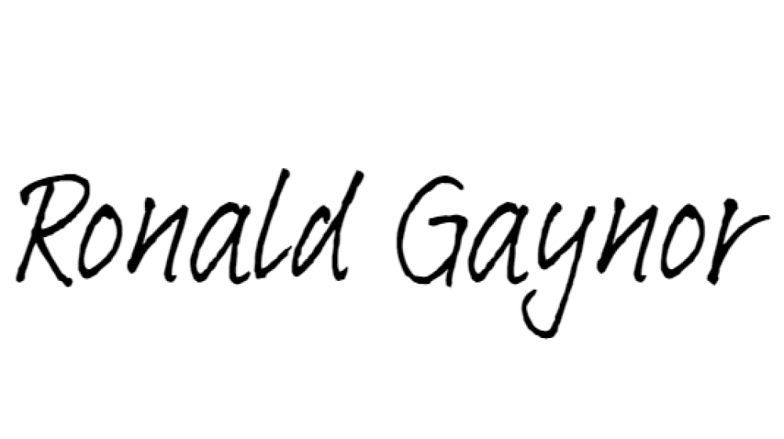
Chairman of the Low-Level Radioactive Waste Forum Executive Director of the Southwestern Compact

