LOW-LEVEL RADIOACTIVE WASTE FORUM   
FALL 2024 MEETING

October 9-10, 2024  
Grand Sierra Resort  
2500 E 2nd St, Reno, NV 89595 1-800-501-2651

**Wednesday: October 9, 2024**

**All times Pacific Daylight Time**

9:00 am – 9:10 am **Welcome and Introductory Remarks**

*Doug Hansen, LLW Forum Chair*

9:10 am – 9:15 am **Welcome to Nevada**

*Tim Robb*

*NWIC Board Member*

*Director of Strategic Initiatives*

*Officer of Governor Joe Lombardo*

9:15 am –10:00 am **Rocky Mountain Low-Level Radioactive Waste Compact:**

**History and Updates***Leonard C. Slosky  
Executive Director, Rocky Mountain Compact*

10:00 am –10:30 am **Introductions and updates from   
LLW Forum Members**

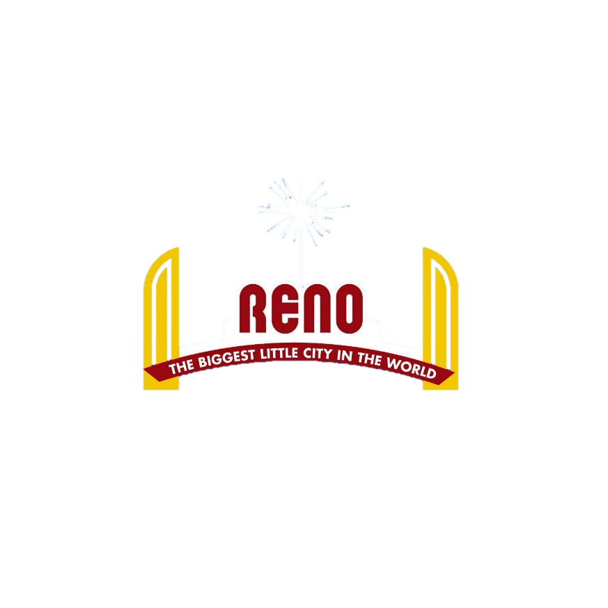

10:30 am – 11:00 am **NRC Update**   
*Duane White, NRC*

11:00 am – 11:30 am ***Networking Break***

11:30 am – 12:00 pm **DOE Waste Management Update**   
*Amie Robinson, DOE*

12:00 pm – 12:30 pm **DOE Environmental Management Activities  
Nevada National Security Site***Robert Boehlecke, DOE NNSS*

12:30 pm – 2:00 pm ***Lunch (provided)***

2:00 pm – 3:00 pm **Updates from United States   
Commercial Disposal Facilities**

*Vern Rogers, EnergySolutions  
David Carlson, Waste Control Specialists*

3:00 pm – 3:30 pm ***Networking Break***

3:30 pm – 4:30 pm **Updates from United States   
Commercial Disposal Facilities (cont.)**

*Doug Frenette, Republic Services  
Andy Veronee, Barnwell*

4:30 pm – 5:00 pm **DOE Update on Disused Sources**  
 *Sam Meyer, DOE NNSA*

5:00 pm – 5:30 pm **GAO Update**  
 *Ned Woodward, GAO*

5:30 pm ***Session Adjourn***



NETWORKING SOCIAL!

**Wednesday, October 9**

**5:30 pm – 8:00 pm**

**Kingpin VIP Bowling Lanes & Lounge**

FREE DRINKS AND FOOD!

**Thursday: October 10, 2024**

**All times Pacific Daylight Time**

9:00am – 9:15am **Business Session (including working group updates and resolutions)***Doug Hansen, LLW Forum Chair*

9:15 am – 9:30 am **Overview of the LLW Forum’s Disused   
Sources Working Group**   
*Michael Klebe, DSWG*

9:30 am – 9:45 am **Update of the Southeast Compact’s   
Source Disposal Funding**

*Tom Hansen, SE Compact  
John McCormack, Bionomics*

9:45 am – 10:15 am **US EPA Program Updates***Dan Schultheisz, EPA*

10:15 am – 10:45 am ***Networking Break***

**check out of hotel**

10:45 am – 11:15 am **NEI Update**

*Bruce Mongomery, NEI*

11:15 am – 11:45 am **EPRI Update**

*Darcy Campbell, EPRI*

11: 45 am – 12:45 pm **History of the Compact System**

**And Discussion**  
*Dan Shrum, LLW Forum*

12:45 pm – 1:00 pm **Wrap-Up***Doug Hansen*

***Adjournment***

**All presentations will be on our website:** [**https://llwforum.org/presentations/**](https://llwforum.org/presentations/)

11:00 am – 11:30 am

